Polymer Chemistry
Notes by
Indranil Chakraborty
Department of Chemistry
Kharagpur College
Part-II
(Molecular forces & chemical bonding in polymers)

Paper-DSE 4T (6th Sem)
Lecture Note-3

TERTIARY STRUCTURE OF POLYMERS

A given polymeric solid material is an aggregate of a large number of polymer molecules. Depending on the molecular structure, the process of molecular aggregation occurs essentially by either of two possible arrangements of molecules, leading to either a crystalline or amorphous material. The forces responsible for molecular aggregation are the intermolecular secondary bonding forces. The overall bonding energies due to secondary bonding forces range from 0.5 to 10 kcal/mol whereas primary bonding forces are of the order 50 to 100 kcal/mol. But when molecules are large enough, the attractive forces resulting from the secondary intermolecular bonding forces may build up to such a level that, in some cases, they become greater than the primary valence forces responsible for intramolecular bonds. Tertiary structure is concerned with the nature of the intermolecular secondary bonding forces and with structural order of the resulting polymer.
A. SECONDARY BONDING FORCES (COHESIVE ENERGY DENSITY)
Secondary bonds consist of dipole, induction, van der Waals, and hydrogen bonds.
- Dipole forces result from the attraction between permanent dipoles associated with polar groups.
- Induction forces arise from the attraction between permanent and induced dipoles.
- Van der Waals (dispersion) forces originate from the time-varying perturbations of the electronic clouds of neighboring atoms.
- Hydrogen bonds are very important in determining the properties of such polymers as polyamides,
polyurethanes, and polyureas.

In general, the magnitude of the bond energies are in the order hydrogen bond ›dipole bond › van der Waals (dispersion) forces. A quantitative measure of the magnitude of secondary bonding forces is the cohesive energy density (CED), which is the total energy per unit volume needed to separate all intermolecular contacts and is given by:
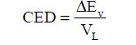
Where, ΔEv = molar energy of vaporization & V_{L} = molar volume of the liquid

CRYSTALLINE AND AMORPHOUS STRUCTURE OF POLYMERS

When a polymer is cooled from the melt or concentrated from a dilute solution, molecules are attracted to each other forming a solid mass. In doing so, two arrangements are essentially possible:
• In the first case, the molecules vitrify, with the polymer chains randomly coiled and entangled. The resulting solid is amorphous and is hard and glassy.
• In the second case, the individual chains are folded and packed in a regular manner characterized by three-dimensional long-range order. The polymer thus formed is said to be crystalline.
Since polymers are made up of long molecules; therefore, the concept of crystallinity in polymers must be viewed slightly differently from that in low-molecular-weight substances. Complete parallel alignment is never achieved in polymeric systems. Only certain clusters of chain segments are aligned to form crystalline domains. These domains do not have the regular shapes of normal crystals. Consequently, no polymer is 100% crystalline.
1. Crystallization Tendency
Secondary bonding forces are responsible for intermolecular bonding in polymers. These forces are effective only at very short molecular distances. Therefore, to maximize the effect of these forces in the process of aggregation of molecules to form a crystalline solid mass, the molecules must come as close together as possible. The tendency for a polymer to crystallize, therefore, depends on the magnitude of the inherent intermolecular bonding forces as well as its structural features.
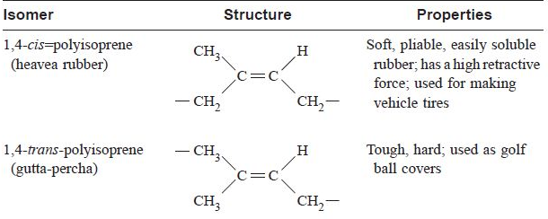
2. Structural Regularity
In the process of association of polymer molecules to form a solid mass, molecules must come as close together as possible.
Polyethylene is nonpolar, and the intermolecular attraction is due to the relatively weak van der Waals forces. The chains can readily assume a planar zigzag conformation characterized by a sequence of trans bonds and can therefore produce short identity periods along the polymer chain length. The rotation around the C–C bond is inhibited by an energy barrier of about 2.7 kcal/mol of bonds. Due to high structural regularity close packing of the chains become possible. Close packing and limited chain flexibility leads to an unexpectedly high melting point (Tm = 135°C), relatively high rigidity, and low room-temperature solubility. However, as irregularities are introduced into the structure, as with low-density polyethylene (LDPE), the value of these properties shows a significant reduction. The crystalline melting point of polyethylene, for example, is reduced 20 to 25°C on going from the linear to the branched polymer. Regularity per se is not sufficient to ensure crystallizability in polymers. The spatial regularity and packing are important. To illustrate this, let us consider two examples of stereoregular polymers. Table 3.8 shows the properties of two isomers: cis- and trans-polyisoprene. It is obvious from the table that the stereoregular trans form is more readily packed and crystallizable and has properties of crystalline polymers. The second example is the stereoregularity displayed by monosubstituted vinyl polymers of olefins. As we saw earlier, these types of polymers can occur in three forms of tacticity: isotactic, syndiotactic, and atactic. Isotactic and syndiotactic polymers possess stereoregular structures. Generally these polymers are rigid, crystallizable, high melting, and relatively insoluble. On the other hand, atactic polymers are soft, low melting, easily soluble, and amorphous.
3. Chain Flexibility
In the preceding discussion, we consistently emphasized that close alignment of polymer molecules is a vital prerequisite for the effective utilization of the intermolecular bonding forces. During crystallization, this alignment and uniform packing of chains are opposed by thermal agitation, which tends to induce segmental, rotational and vibrational motions. The potential energy barriers hindering this rotation range from 1 to 5 kcal/mol, the same order of magnitude as molecular cohesion forces. It is to be expected, therefore, that those polymers whose chains are flexible will be more susceptible to this thermal agitation than those with rigid or stiff chain structure.
The flexibility of chain molecules arises from rotation around saturated chain bonds. With a chain of –CH2– units as a basis, it is interesting to consider how variations on this unit will affect rotation of adjacent units and, hence, chain flexibility. Studies of this type have led to the following general conclusions:
• Rapid conformational change due to ease of rotation around single bonds occurs if such groups as
(– –CO–O–), (–O–CO–O–), and (–C–N–) are introduced into the main chain. If they are regular and/or if there exist considerable intermolecular forces, the materials are crystallizable, relatively high melting, rigid, and soluble with difficulty. However, if they occur irregularly along the polymer chain, they are amorphous, soft, and rubbery materials.

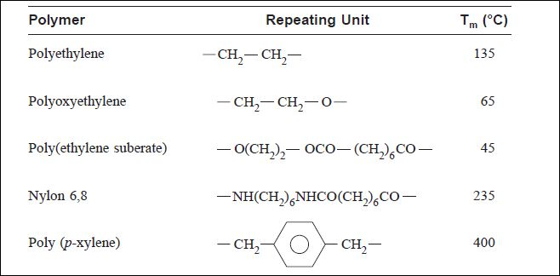
• Ether and imine bonds and double bonds in the cis form reduce the energy barrier for rotation of the adjacent bonds and “soften” the chain by making polymers less rigid, more rubbery, and more readily soluble than the corresponding chain of consecutive carbon–carbon atoms. If such “plasticizing” bonds are irregularly distributed along the polymer chain length, crystallization is inhibited.
• Cyclic structures in the backbone and polar group such as –SO2–, and –CONH– drastically reduce
flexibility and enhance crystallizability.
4. Polarity
When molecules come together and aggregate into a crystalline solid, a significant cohesion between neighboring chains is possible. Consequently, polymer molecules with specific groups that are capable of forming strong intermolecular bonding, particularly if these groups occur regularly without imposing valence strains on the chains, are crystallizable. You will recall from our earlier discussion that such groups as
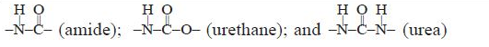
provide sites for hydrogen bonding whose energy ranges from 5 to 10 kal/mol. In nylon 6 or 6,6, for example, the regular occurrence of amide linkages leads to a highly crystalline, high melting polymer. Molecules whose backbone contains –O– units or with polar side groups (–CN, –Cl, –F, or –NO2)
exhibit polar bonding. The bonding energies of such dipoles or polarizable units are in the range between hydrogen bonding and van der Waals bonding. If these groups occur regularly along the chain (isotactic and syndiotactic), the resulting polymers are usually crystalline and have higher melting points than polyethylene

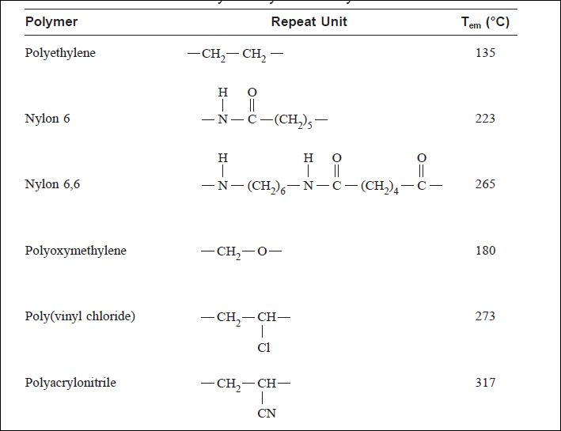
Given our earlier argument that the presence of –O– units in a chain backbone enhances flexibility, the fact that the melting point of polyoxymethylene (180°C) is higher than that of polyethylene (135°C) (Table 3.10) seems contradictory. However, the dipole character of the C–O–C group produces polar forces between adjacent chains that act over a longer range and are stronger than van der Waals forces. Thus, for polyoxymethylene the induced flexibility is more than offset by the increased bonding forces resulting from polarity.
5. Bulky Substituents
The vibrational and rotational mobility of intrinsically flexible chains can be inhibited by bulky substituents; the degree of stiffening depends on the size, shape, and mutual interaction of the substituents. For example, vinyl polymers with small substituents such as polypropylene [–CH3] and polystyrene [–C6H5] can crystallize if these pendant groups are spaced regularly on the polymer chain as in their isotactic and syndiotactic forms. In their atactic forms, the randomly disposed pendant groups prevent the close packing of the chains into crystalline lattice. The atactic forms of these polymers are therefore amorphous. Large or bulky substituents, on the other hand, increase the average distance between chains and, as such, prevent the effective and favorable utilization of the intermolecular bonding forces. Thus polymers like poly(methyl acrylate) and poly(vinyl acetate) with large pendant groups – O|| C–O–CH 3 and O– O || C–CH 3 , respectively, cannot crystallize even if the pendant groups are spaced regularly (isotactic and syndiotactic forms). Note that for the polyolefins, polyethylene, polypropylene, poly(1-butene), and poly(1-pentene), the melting point shows a maximum for polypropylene. A large pendant group in close proximity of the main chain stiffens the chain. However, when the size of the pendant group is such that the packing distance between the chains in the solid state is increased, the forces of interaction between chains decrease and so does the melting point. The presence of an aromatic side group in polystyrene considerably stiffens the chain, which has a stable helix form in the solid state. The helices pack efficiently to allow greater interchain interaction. The above discussion clearly indicates that stereo regularity, chain flexibility, polarity, and other steric factors have profound influence on crystallizability and melting points and, hence, as we shall see later, play an important role in the thermal and mechanical behavior of polymers.

